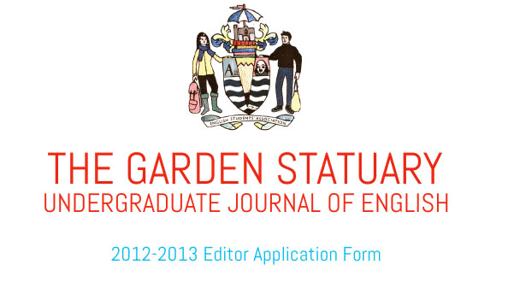
Please email the completed form to thegardenstatuary@gmail.com

Contact
Name

Email

Phone #

Year Major

Field of Interests
The Garden Statuary publishes academic essays in the field of English, fiction, stage/screenplay, poetry, and creative nonfiction. We also showcase photography, visual art, film and music. Please specify which genre(s) you are interested in working with.

Related Experience
Please describe any experience you have working with the genres of interest you listed above (i.e.: as a writer, creator and/or editor). If you have any experience working with a literary journal, we’d also love to hear about it!

Other Experience
Please describe any other experience or skills you feel would contribute to TGS such as graphic design, marketing, event planning, general project management, etc.

Tell Us About Yourself!
Why are you interested in being an editor for The Garden Statuary?

Optional
You may attach a copy of your resume in your email if you feel that it strengthens your application or reflects on skills otherwise not mentioned here.

Thank you for supporting The Garden Statuary! We’ll be in touch!

